

Rev.1.0 February 04th, 2020

Firmware Downloader

User’s Manual

[www.swhwc.com](http://www.swhwc.com/)

Table of Contents

1. Introduction 3

1.1 Introduction 3

1.2 Prerequisite 3

2. Application configuration 4

2.1 settings.ini 4

3. Run application 5

4. Revision history 7

# Introduction

## Introduction

This document guidelines how to run Firmware Downloader application on Windows.

## Prerequisite

To run Firmware Downloader, a host PC is required.

* Host PC:
  + OS: Windows OS (Windows 10 is recommended)
  + .NET Framework ([4.6.1](https://dotnet.microsoft.com/download/dotnet-framework/net461) or later)
  + J-Link Software: ([V6.44i](https://www.segger.com/downloads/jlink/JLink_Windows_V644i.exe) or later)

# Application configuration

The Firmware Downloader application contains:

* FirmwareDownloader.exe: Application binary file.
* settings.ini: configuration for this application.
* script.jlink: J-Link commander script.
* ble_app_template_pca10040e_s112.hex: firmware to download to the devices.
* INIFileParser.dll: library file.

## settings.ini

|  |
| --- |
| [SerialNo]  Start = 20000001  Max = 100  Length = 8  Address = 0x2fff0  [System]  JLINK = "C:\Program Files (x86)\SEGGER\JLink_V644i\JLink.exe" |

* SerialNo
  + Start: Start value of serial number to write to the devices.
  + Max: maximum number of devices to write to.
  + Length: The length of serial number (It is fixed to 8).
  + Address: Address of serial number in flash memory (It is fixed to 0x2fff0).
* System
  + JLINK: The full path to J-Link software.

# Run application

When application starts, it will show a serial number. This serial number will be written to the device if we click “Start” button.

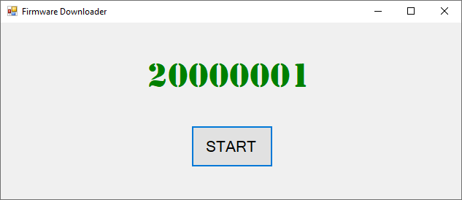

When we click “Start” button, the application will download the firmware and write the serial number to the device.

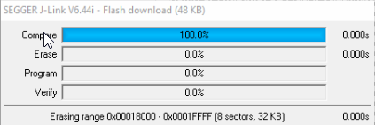

After the download is successful, the serial number will be increased.

The maximum number of devices will also be decreased.

Below message box will be shown when the maximum count is reached.

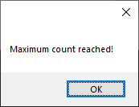

And “Start” button will be disabled when the maximum count is reached.

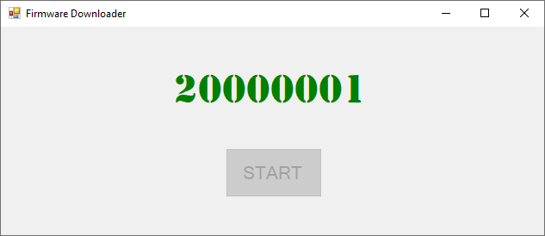

# Revision history

|  |  |  |  |
| --- | --- | --- | --- |
| Rev. | Date | Description | |
| Page | Summary |
| 1.0 | Feb 04th, 2020 | - | First release |
|  |  |  |  |
|  |  |  |  |
|  |  |  |  |